Lab Assignment-4

ECSE373L: Cloud Infrastructure and Services

**Name:** Tanvi Penumudy

**Enroll no**: E18CSE187

**Batch:** EB02

**AWS Educate Console Name:** vocstartsoft/user1199245=TP6145@bennett.edu.in

**Lab Activities:**

**Task 0:**  Create the Role of Full Dynamo DB service using IAM service.

**Task 1:**  Create Lambda function and configure it with S3 bucket and DynamoDB database

**Task 2:**  Add a trigger for uploading objects in S3 Bucket

**Task 3:** Create a table in DynamoDB and check the details of the items

**Task 4:** Check the proper working of Lambda Function

**Task 5:** Take the snapshots of all performed tasks and create a doc/pdf of your enrolment number_lab04 and upload the file on LMS.

**Task 0**

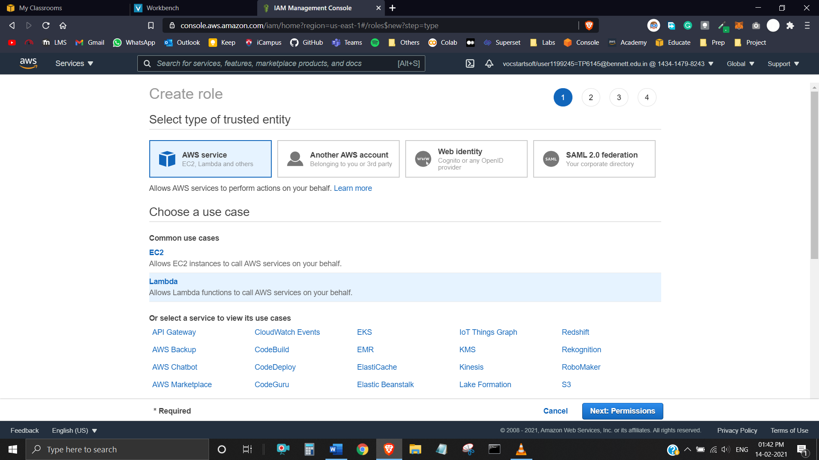

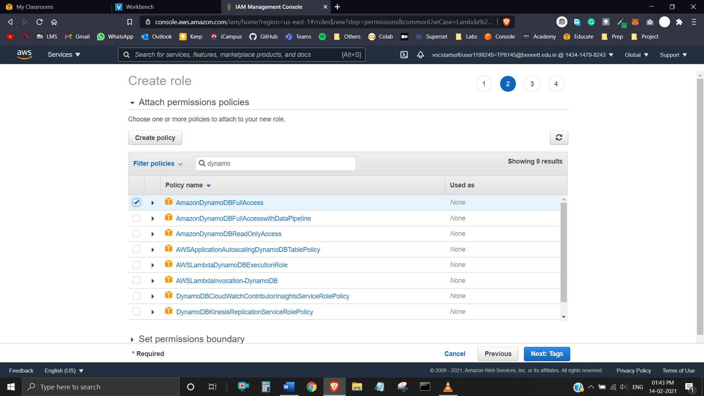

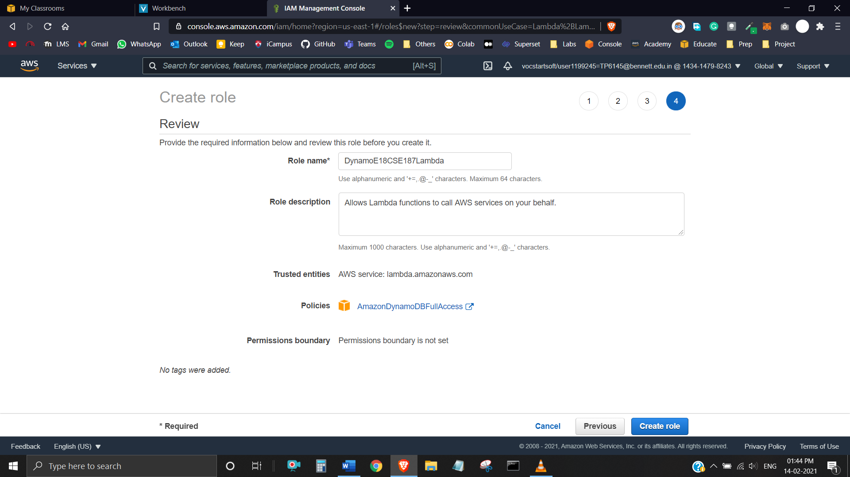

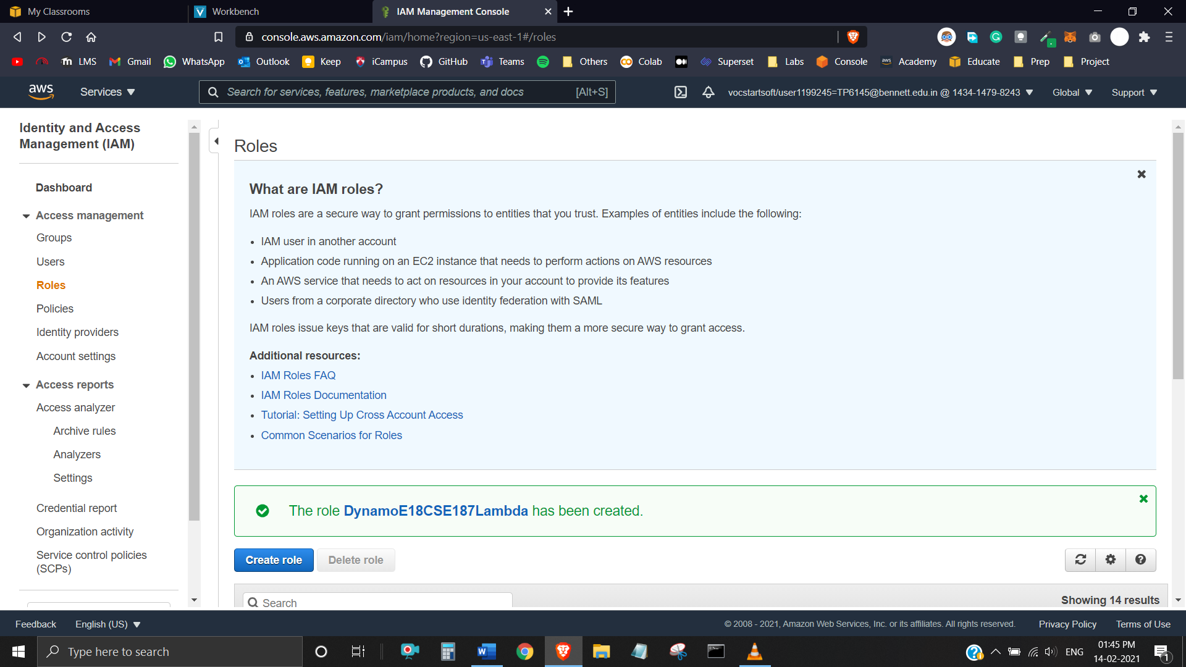

**Task 1**

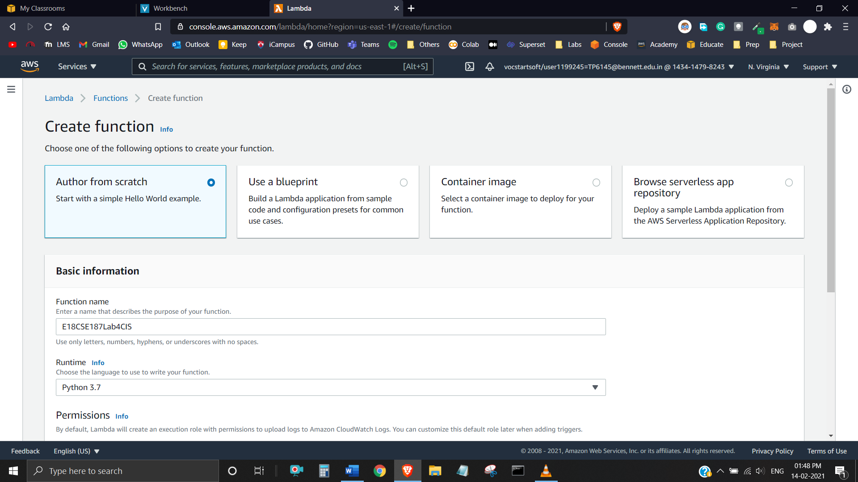

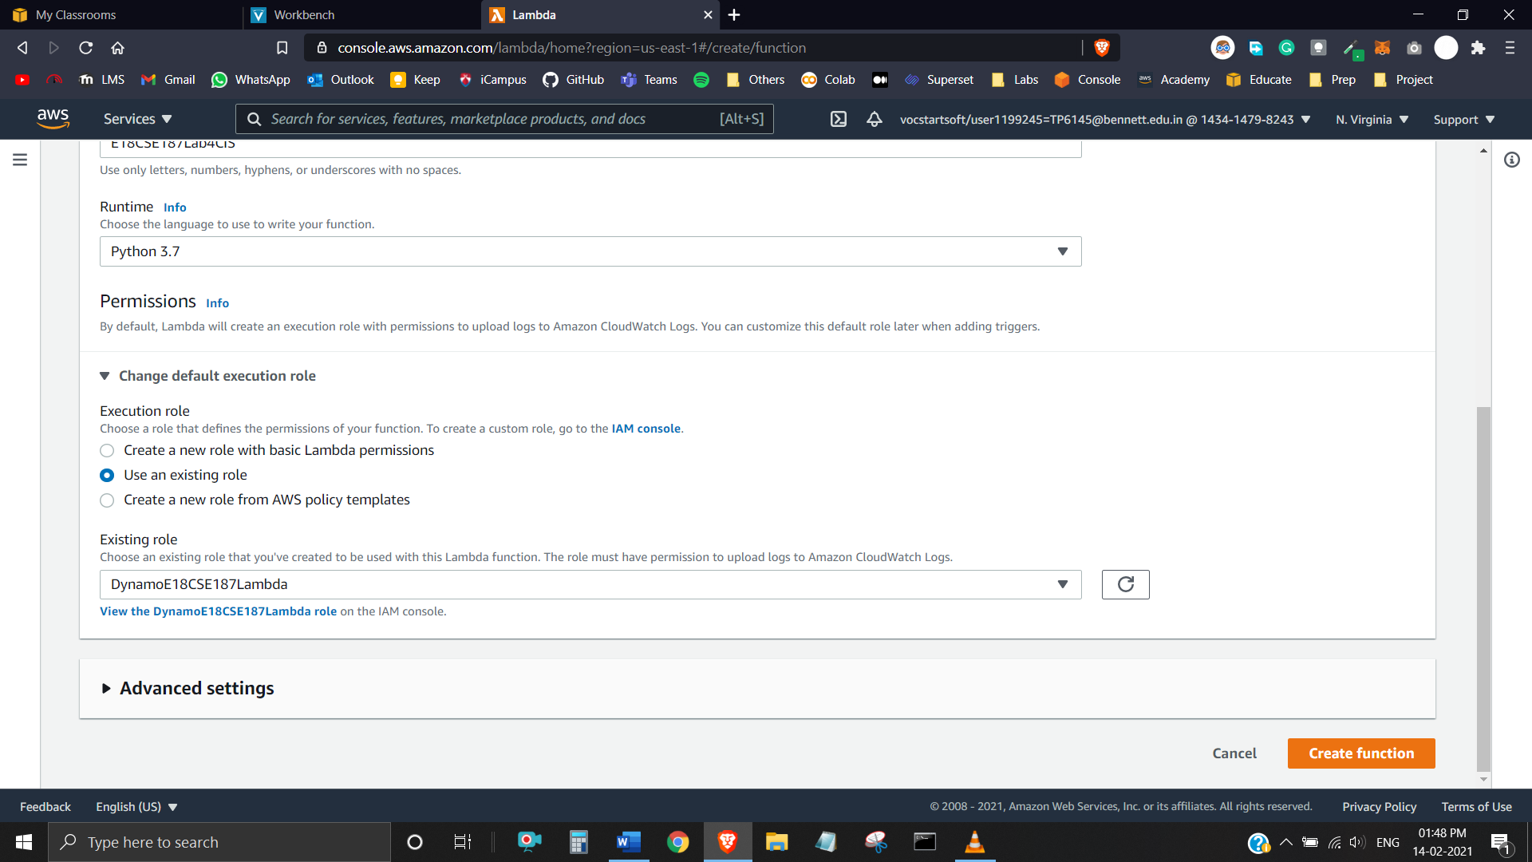

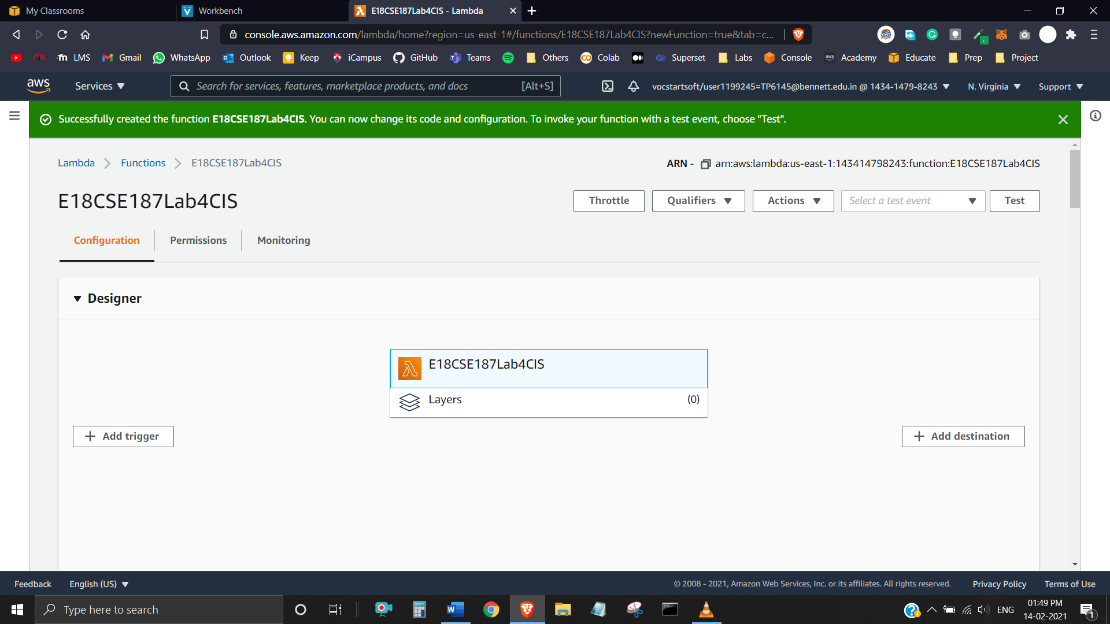

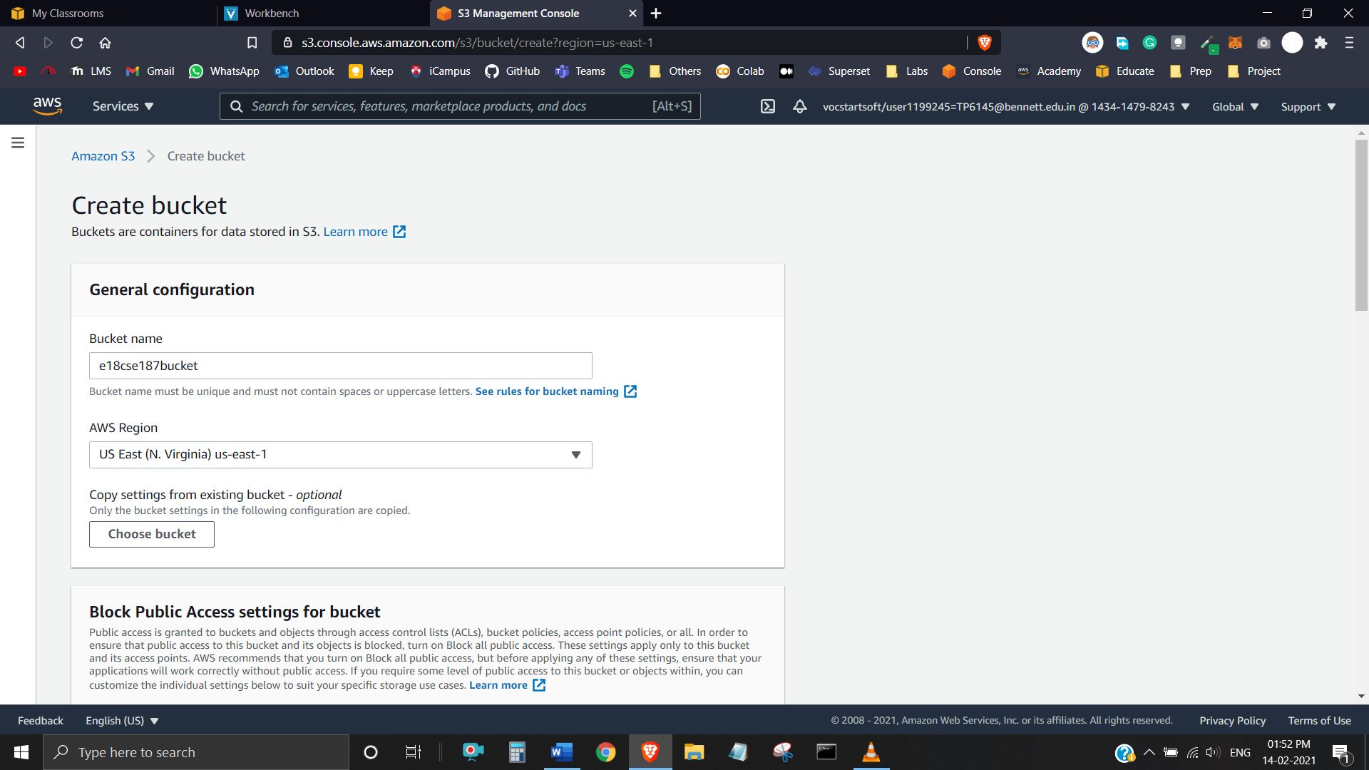

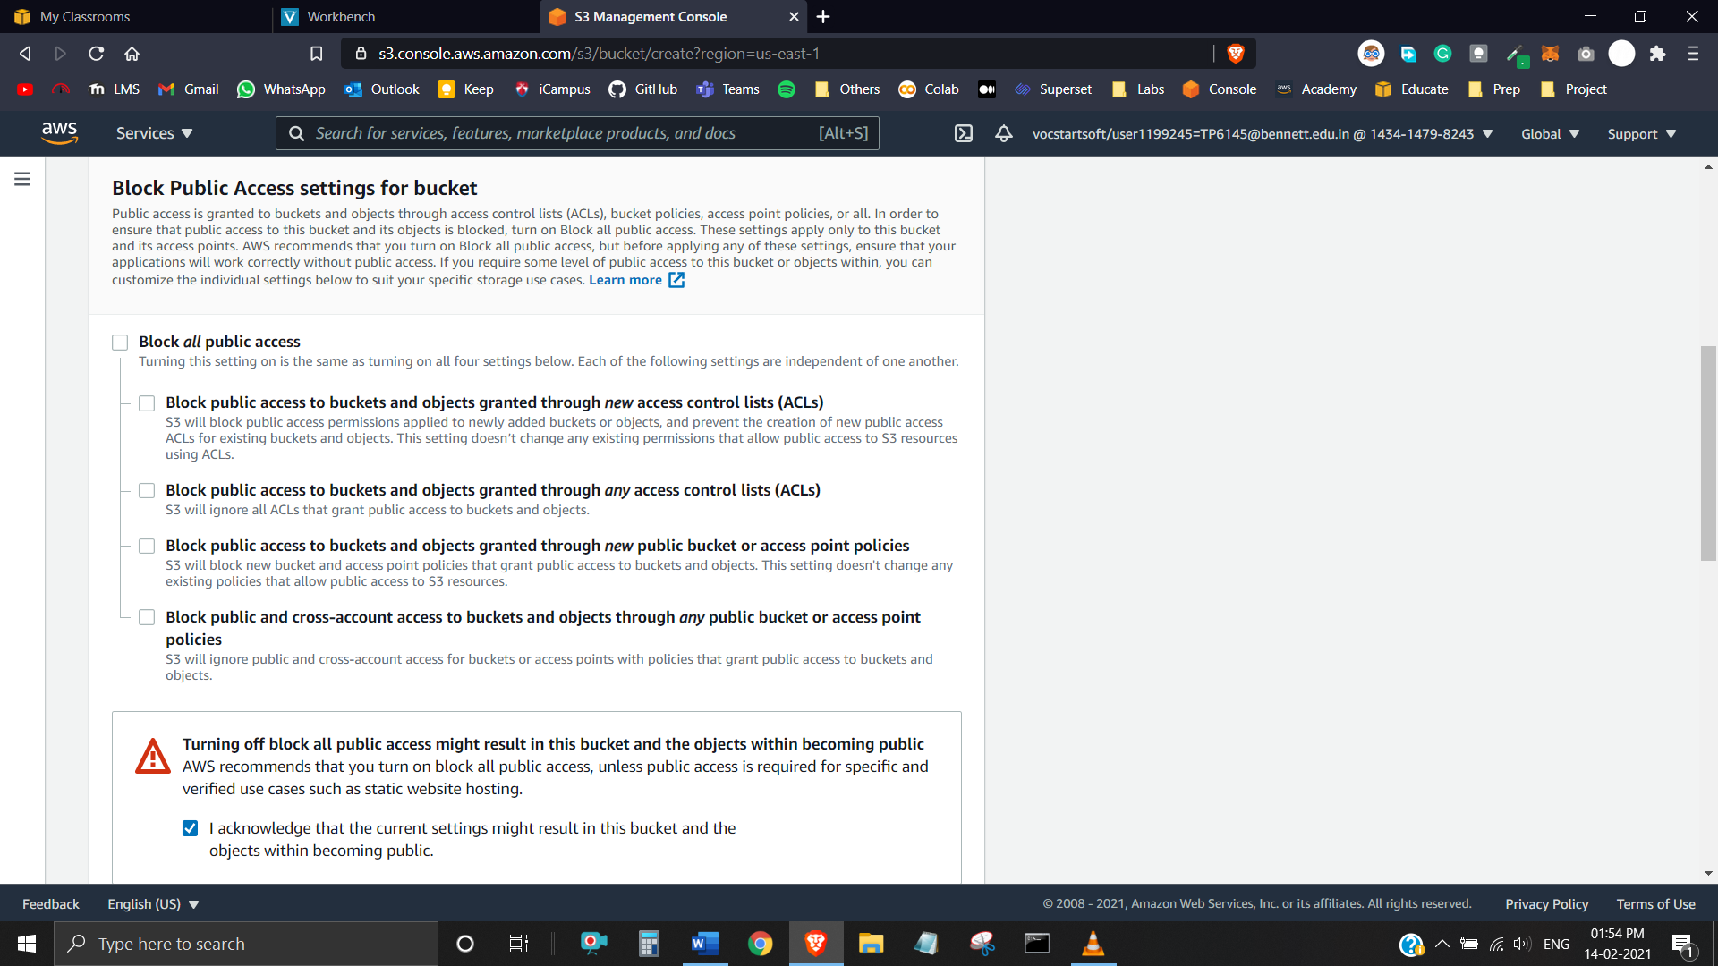

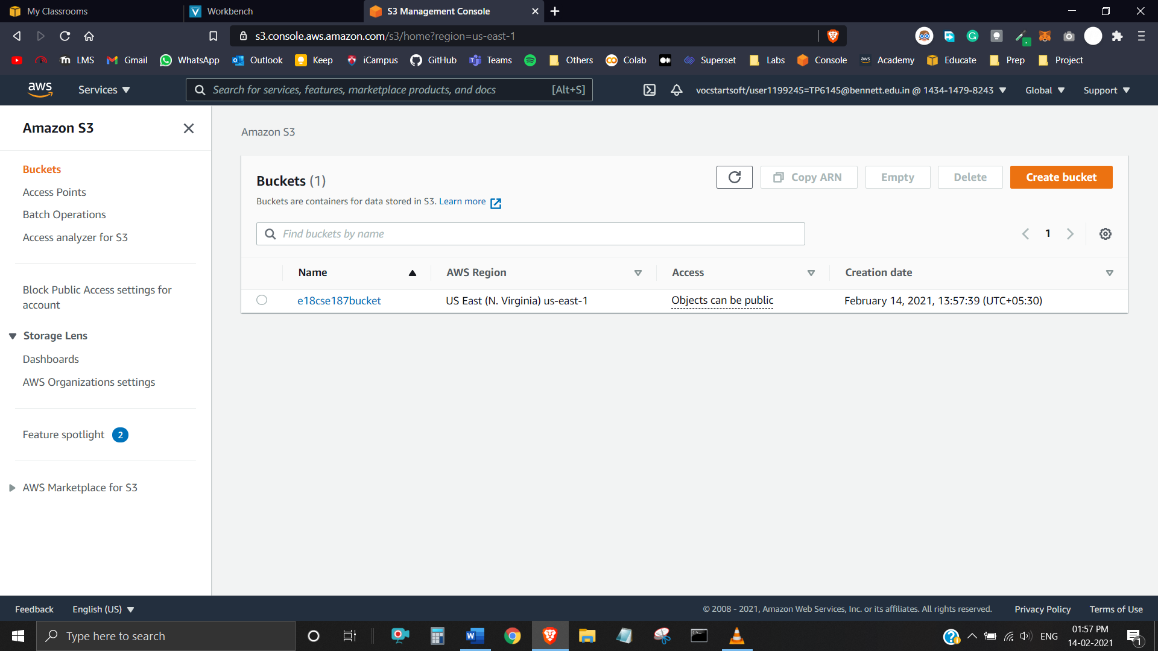

**Task 2**

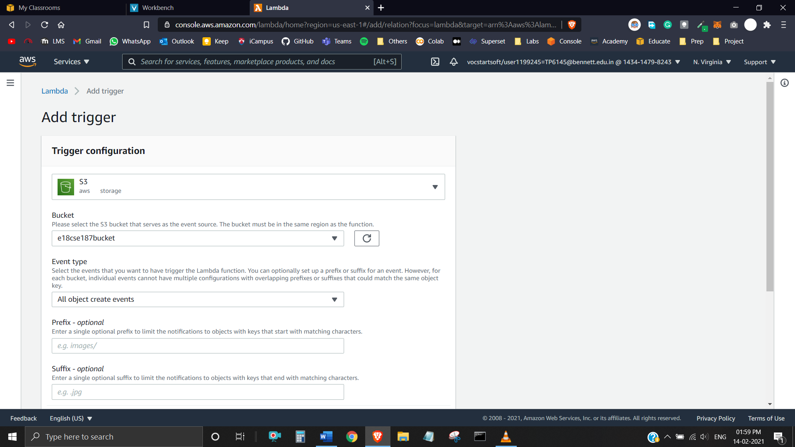

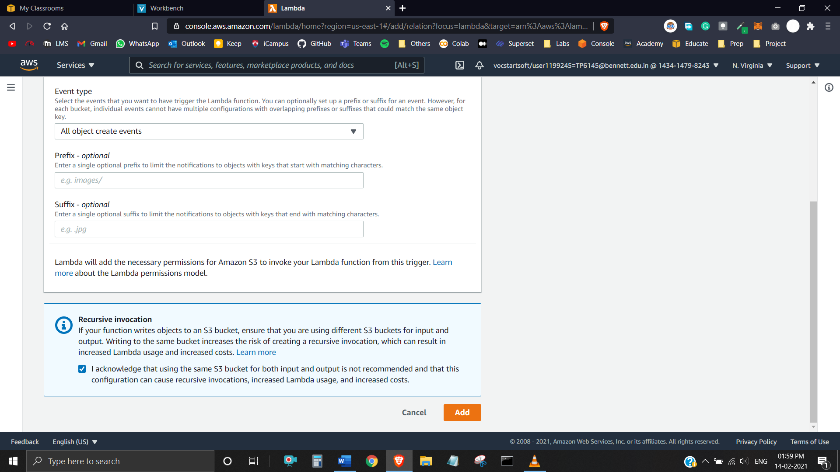

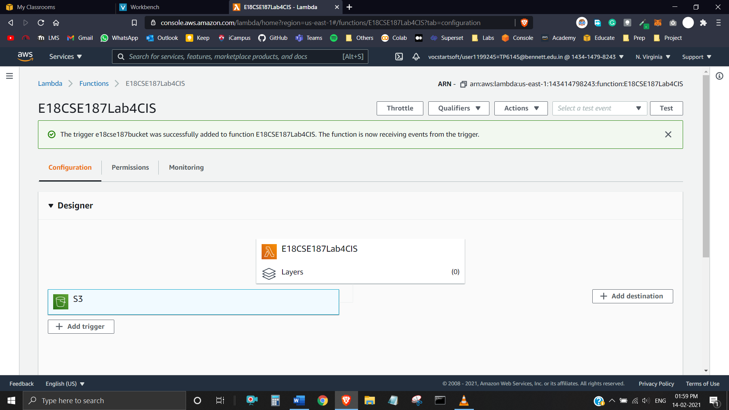

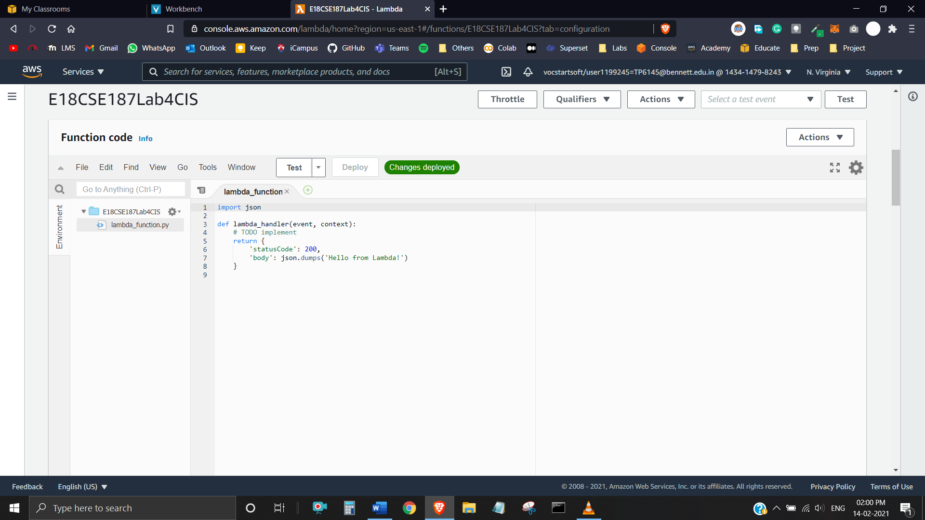

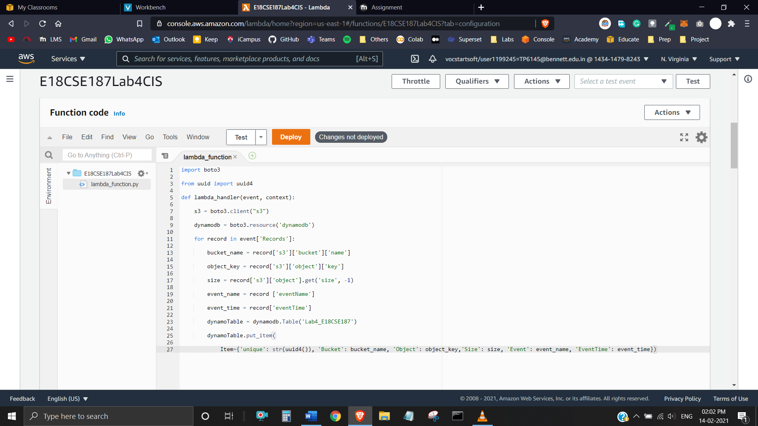

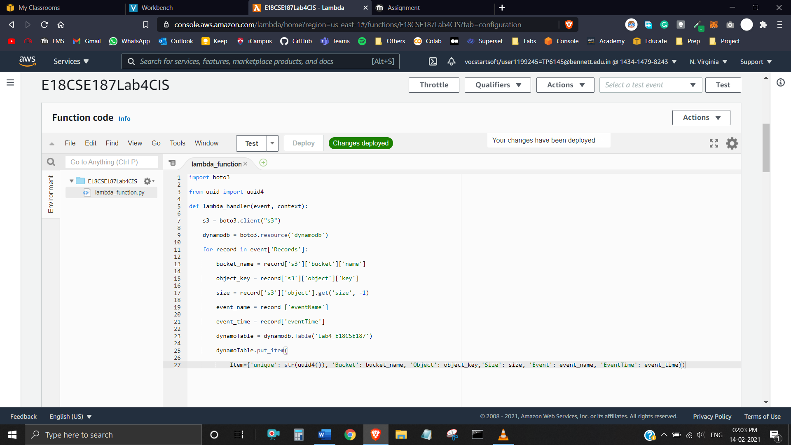

**Task 3**

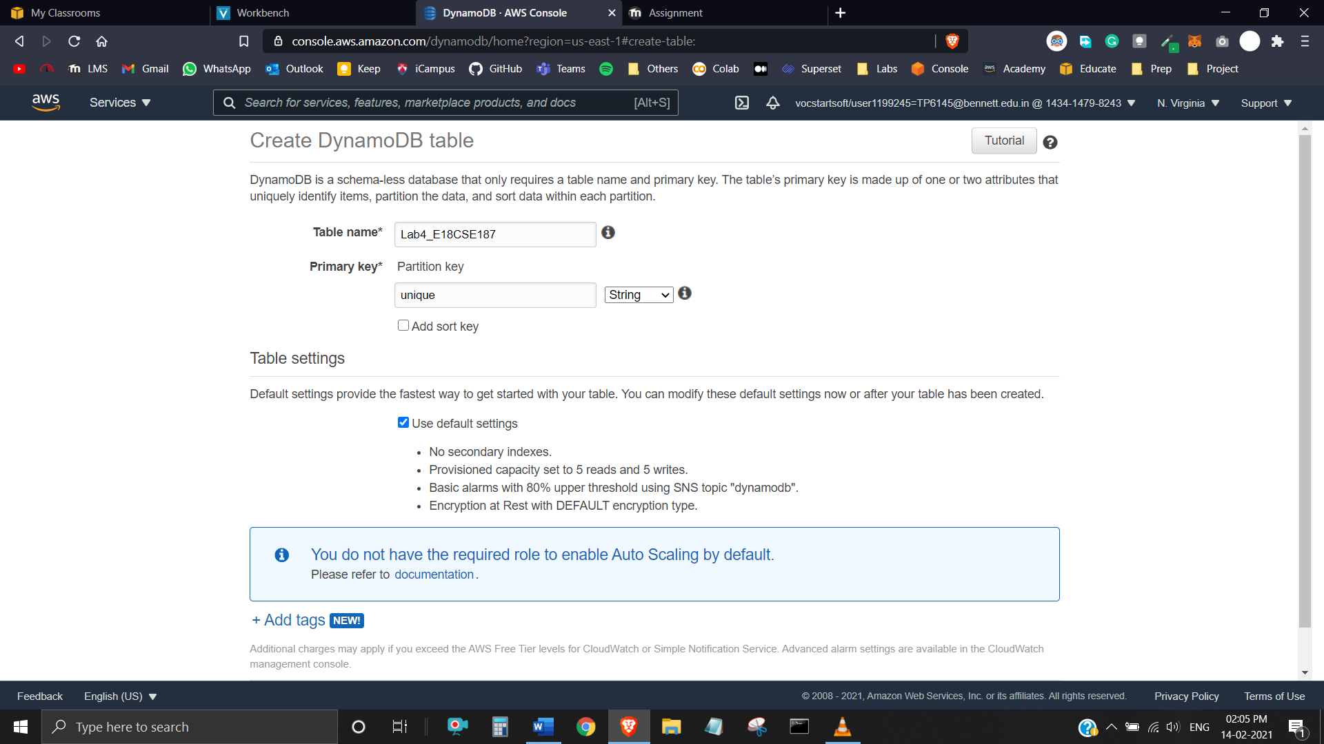

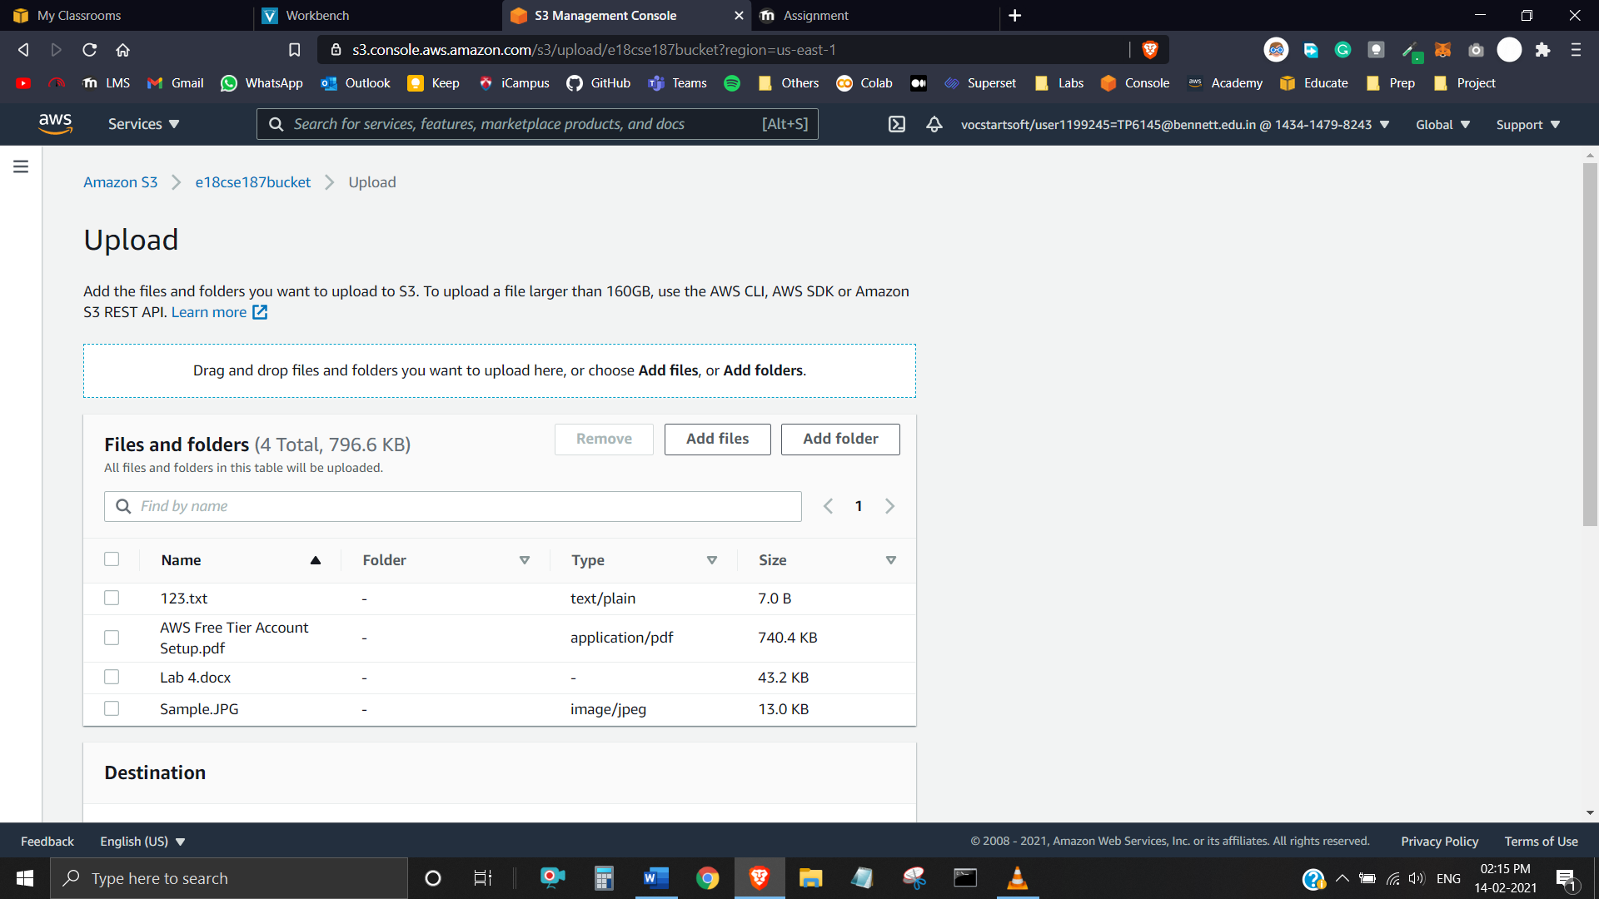

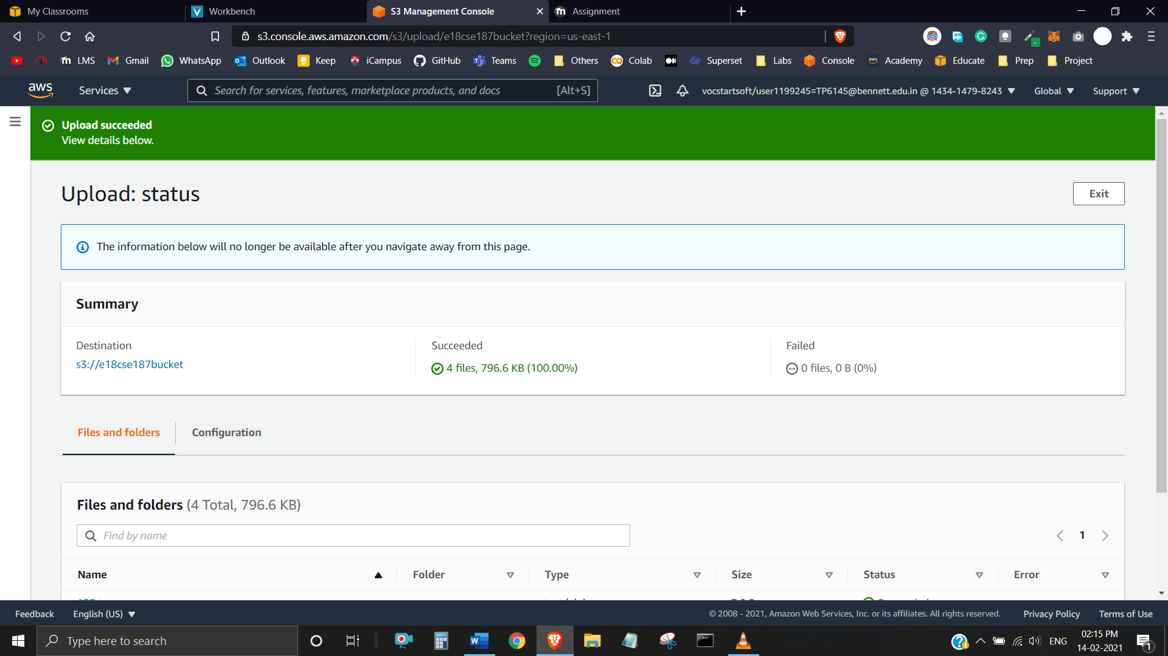

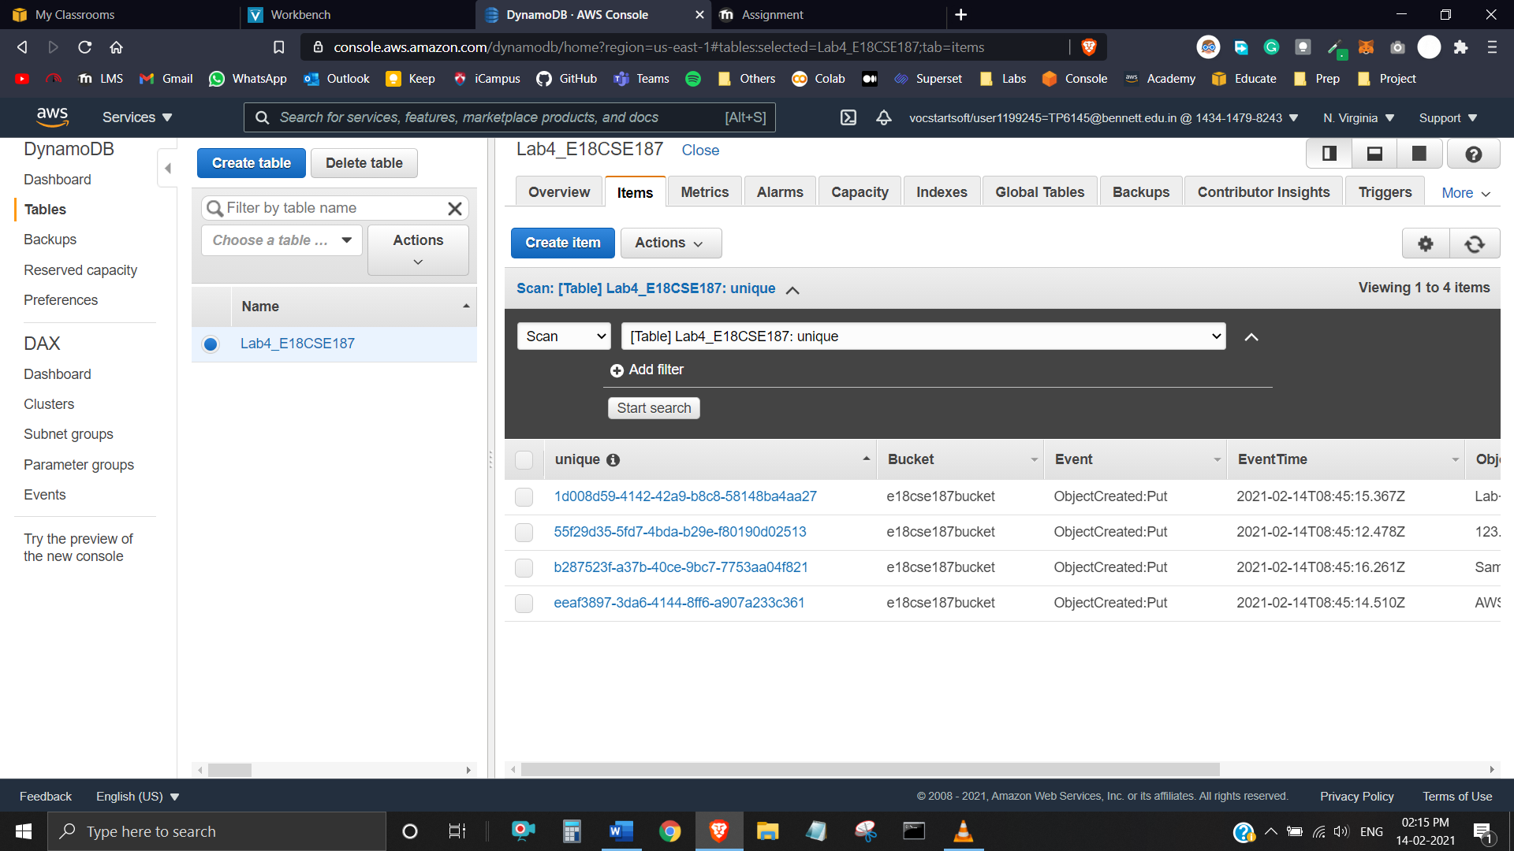

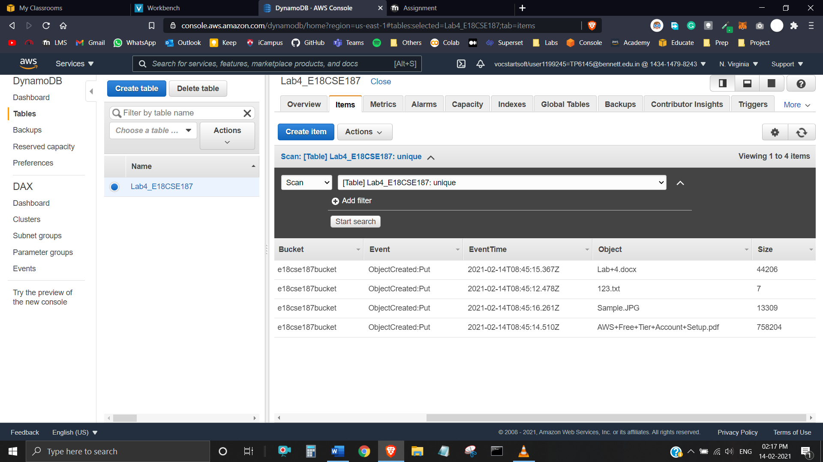

**Task 4**

